Installing Jenkins SOP



Table of Contents

- Installing Jenkins ........................................................................................................................ 3
  - Description........................................................................................................................... 3
  - Architecture Diagram ............................................................................................................. 3
  - Lab Steps ............................................................................................................................ 4
  - Troubleshooting .................................................................................................................... 8 1.5 Supporting References .......................................................................................................... 8

1. Installing Jenkins

1.1 Description
In this era one of the biggest challenges for the software company is to provide quick response to their customers and also the quick delivery of their product in the market. In this lab we will install and configure a Jenkins server so that we use it in order to do continuous integration.
In order to accomplish this, you will need to: • Install Java JDK 8 or later
- Configure the Jenkins YUM repository
- Get the temporary admin password and use it to log in to Jenkins

1.2 Architecture Diagram
The diagram below displays a visual representation of the application architecture:

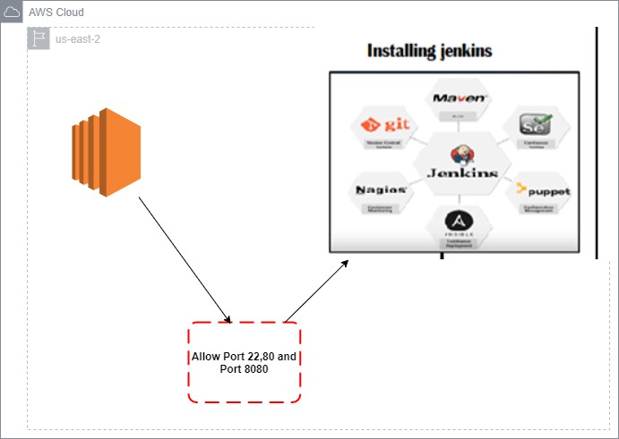

1.3 Lab Steps
Follow the steps outlined below to achieve the objective of this lab exercise:

- Create an EC2 Instance with the following configuration:
  - Choose Amazon Linux 2 AMI with 64-bit(x86).
Note: You can choose other Linux AMI as well but this lab works best in Amazon Linux 2 AMI. b. Choose a t2.micro as an instance type.
  - Leave the configure instance details with their default values.
  - Leave the add storage section with its default values.
Note: If you want more volume, you can increase the volume using this section.
  - In this step add key as Name and in value section specify name like XYZ you want to give to your EC2 Instance.
  - Configure Security group and add HTTP (Port 80) and Custom TCP (Port 8080) and SSH (Port 22) to your group.
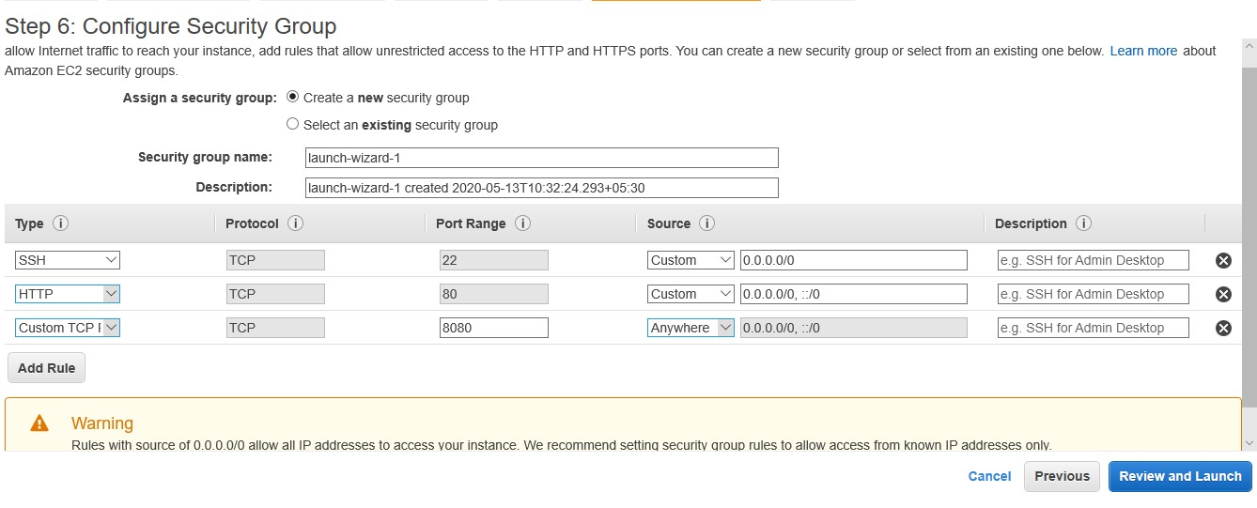

  - Review the complete configuration.
  - Click on Launch instance and then a pop up will open - create a new key pair and download it in your PC. A .pem file gets downloaded.
  - Launch the EC2 Instance.

- SSH into your EC2 Instance using your command prompt or PuTTY:

Tip: If using PuTTY – watch video for instructions on how to connect:
https://www.youtube.com/watch?v=bi7ow5NGC-U
If using command prompt, first change SSH key permissions:
https://superuser.com/questions/1296024/windows-ssh-permissions-for-private-key-are-too-open

  - In the command prompt enter the following to connect to your EC2 instance:
ssh -i C:\Users\"Ankit Verma"\Downloads\devops2.pem ec2-user@3.12.85.68

  - C:\Users\"Ankit Verma"\Downloads\devops2.pem is the address where you have kept your Key that is required to connect with your EC2 instance.
  - 3.12.85.68 is the IP address of the EC2 Instance. Replace it with your EC2 Instance’s IPv4 address.

- After connecting to your EC2 Instance [Linux] execute the following command:
sudo su
- It will take you to the root user then update your EC2 Instance with the following command:
yum update -y
- Next step is installing Java and epel release package:
sudo yum -y install java-1.8.0openjdk
sudo amazon-linux-extras install epel
- Install Jenkin YUM repository:
sudo wget -O /etc/yum.repos.d/jenkins.repo http://pkg.jenkins-ci.org/redhatstable/jenkins.repo
- Install the Jenkins Key:
sudo rpm --import https://jenkins-ci.org/redhat/jenkins-ci.org.key
- Install the Jenkin:
sudo yum –y install jenkins
- Start the Jenkins service:
service jenkins start chkconfig jenkins on

- In a web browser, navigate to the instance IP address [you can find the IP in your EC2 AWS console] followed by port 8080:

<Your IP Address>:8080
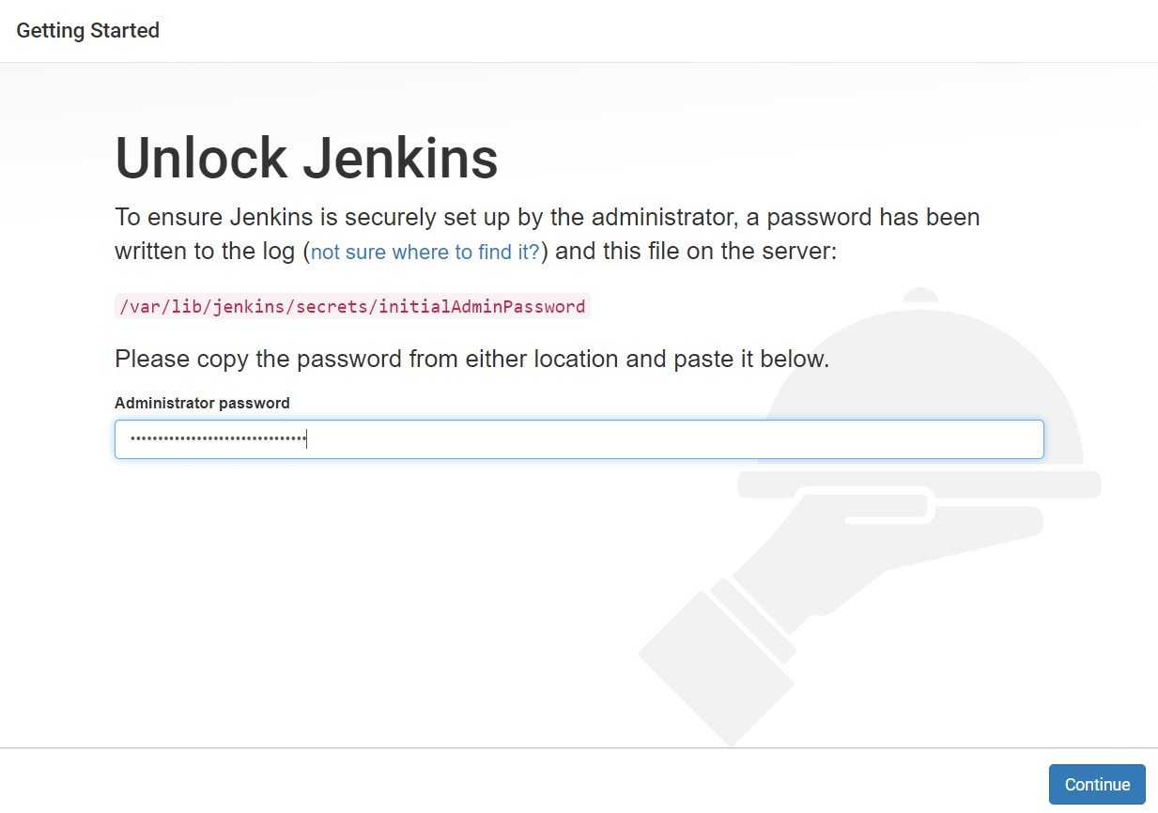
Example: 3.23.115.149:8080

A

screen like the following gets displayed:

- To find the administrator password, return to the command prompt session where you connected to the EC2 instance and type the following command:
cat /var/lib/jenkins/secrets/initialAdminPassword
- This will display the temporary password. Copy the password.
- In the browser, paste this temporary administrator password into the text box provided.

- Click Install suggested plugins.
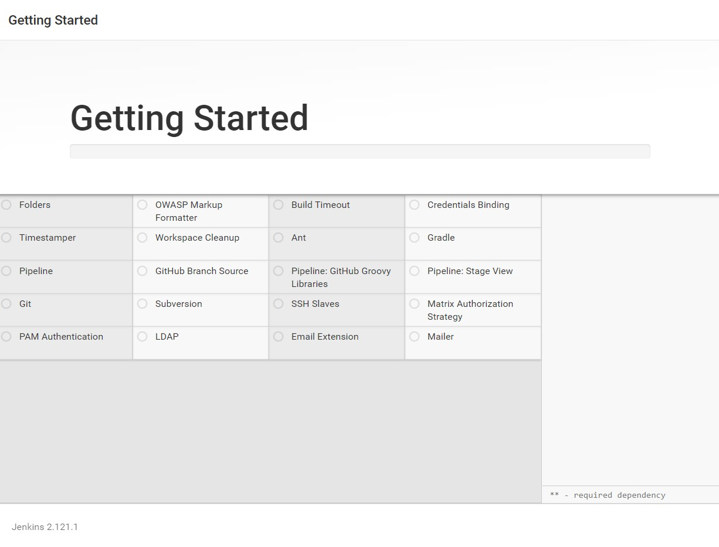

15.

Enter details for a new
admin

user.

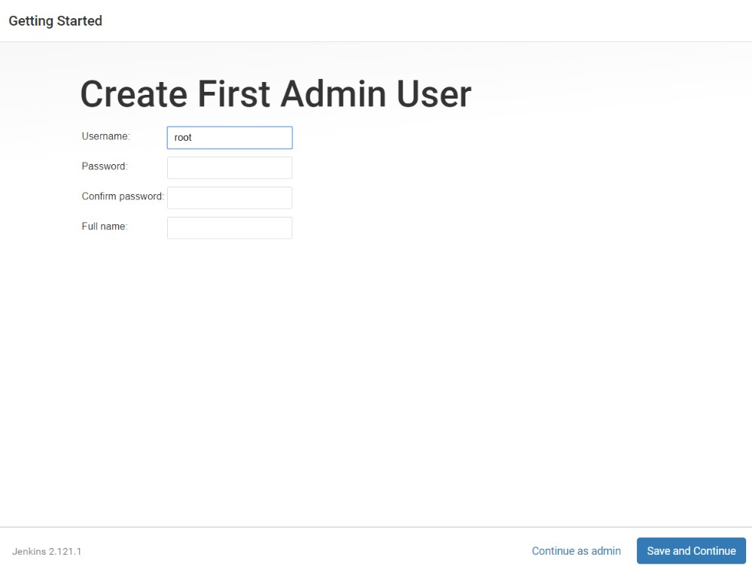
16.

Click
Save

and
Finish
.

Note: Jenkins has now been successfully installed.
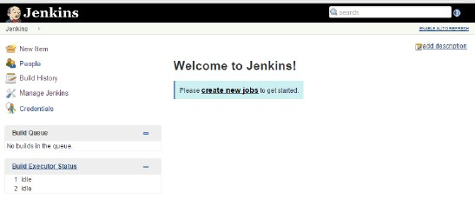
1.4

Troubleshooting

S. No | Problem | Solution
1 | Connection Refused | While connecting your EC2 Instance you may get connection timeout error then check security group of your instance and if you have not added SSH port 22 there add it.
2 | Yum lock | - In this we need a particular process.  Check if all the process running ps aux  - and enter the following for killing the process that is taking more than the required time kill <Process ID>
3 | The site cannot be reached | This error occurs when you are not accessing your Jenkins on port 8080 for which you have enabled it. It can also occur if you have not given proper permission in security group.
4 | If installation of plugins fails then it may be the issue with the version of Jenkins you are using. | To solve this problem, type the following  command: sudo yum update jenkins

1.5 Supporting References
Refer the below links for additional information:

- Installing Jenkins on RedHat distributions:
https://wiki.jenkins.io/display/JENKINS/Installing+Jenkins+on+Red+Hat+distributions
- Jenkins installation documentation for other environments: https://jenkins.io/doc/book/installing/

